**Coffee Sales Analysis Report**

**Problem Statement**

To understand coffee sales patterns across different timeframes, coffee types, and payment methods to make data-driven decisions. Despite having transactional data, they lack clarity on what’s driving sales performance over days, hours, and product categories.

**Objective**

To analyze and visualize sales data to:

* Identify trends in coffee sales by **month**, **day**, and **hour**.
* Determine the **most popular coffee types**.
* Evaluate **payment preferences** (card vs. cash).
* Highlight peak sales periods to optimize staffing and inventory.
* Provide actionable recommendations for maximizing revenue.

**Requirement Analysis**

* **Data Inputs Required:**
  + Date & time of transaction
  + Coffee type sold
  + Price
  + Payment method
* **Tools Used:**

**• ML(Jupyter Notebook):**for Data prepration,data cleaning and basic machine learnig

* Exploratory Data Analysis

• **MySQL:** For storing and querying sales data.

• **Excel:** For initial data cleaning and preparation.

* + Microsoft Excel (with Pivot Tables and Charts)
  + Slicers for month, day, and coffee type filtering
* **KPIs Visualized:**
  + Total Revenue: **37,508.88**
  + Number of Transactions: **1,133**
  + Monthly, daily, and hourly sales patterns
  + Sales distribution by coffee type
  + Preferred payment method

**Key Insights & Recommendations**

1. **Monthly Sales Trend**:
   * Peak sales occurred in **May**, followed by a declining trend till **July**.
   * **Recommendation**: Investigate reasons for the drop in June and July (seasonality, promotions, competition) and introduce incentives during off-peak months.
2. **Top-Selling Coffee Types**:
   * **Latte**, **Americano with milk**, and **Cappuccino** are the most popular.
   * **Recommendation**: Upsell or bundle top-performers; consider promotional pricing for underperforming items like **Espresso** or **Hot Chocolate**.
3. **Day-wise Sales**:
   * **Tuesday** shows the highest sales, but all days are fairly consistent.
   * **Recommendation**: Run targeted mid-week loyalty programs or Monday promotions to increase weekday footfall.
4. **Hourly Sales Analysis**:
   * Peak hours: **10 AM** and **6 PM**.
   * **Recommendation**: Schedule more staff during peak hours, and run early-bird or late-night offers to fill slower slots.
5. **Payment Preferences**:
   * Majority prefer **card payments**.
   * **Recommendation**: Emphasize digital payments with loyalty points; reduce dependency on cash handling.

**Result**

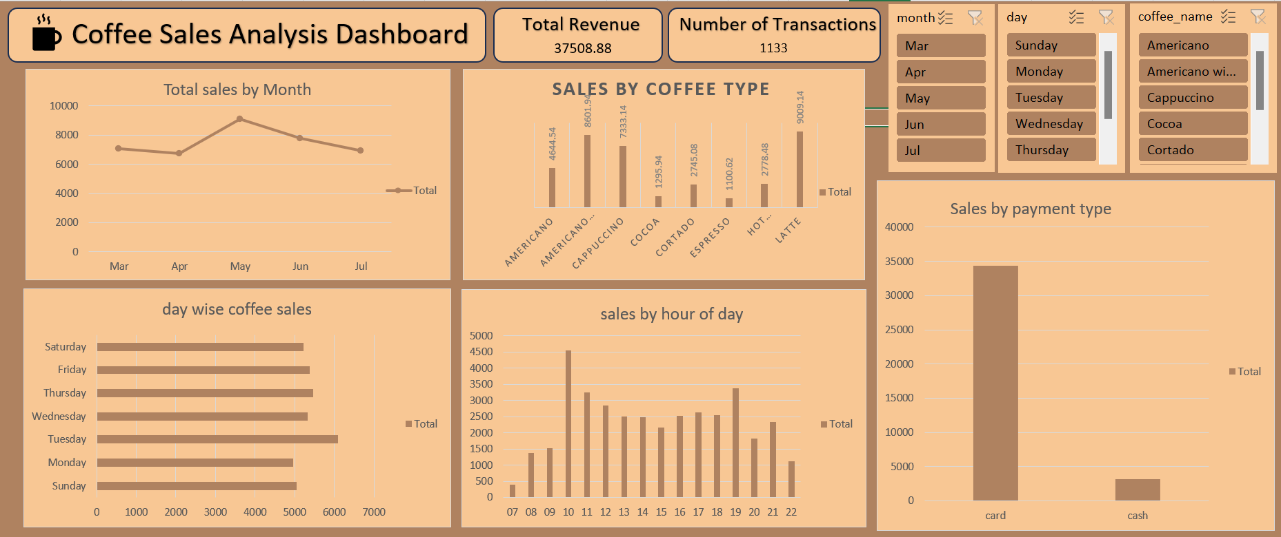

**Conclusion**

The dashboard offers clear, actionable insights into sales trends and customer behavior. By focusing on product popularity, optimal sales windows, and consumer preferences, the café can tailor marketing, inventory, and staffing decisions to boost overall profitability and customer satisfaction.